Test Case: tc005_SPX_Dev5_Crear_Requisicion_Spot_Con_FAD_Tipo_Cobro_Project
Step 1 - Enter username and password and click to button Enter: Credentials Entered
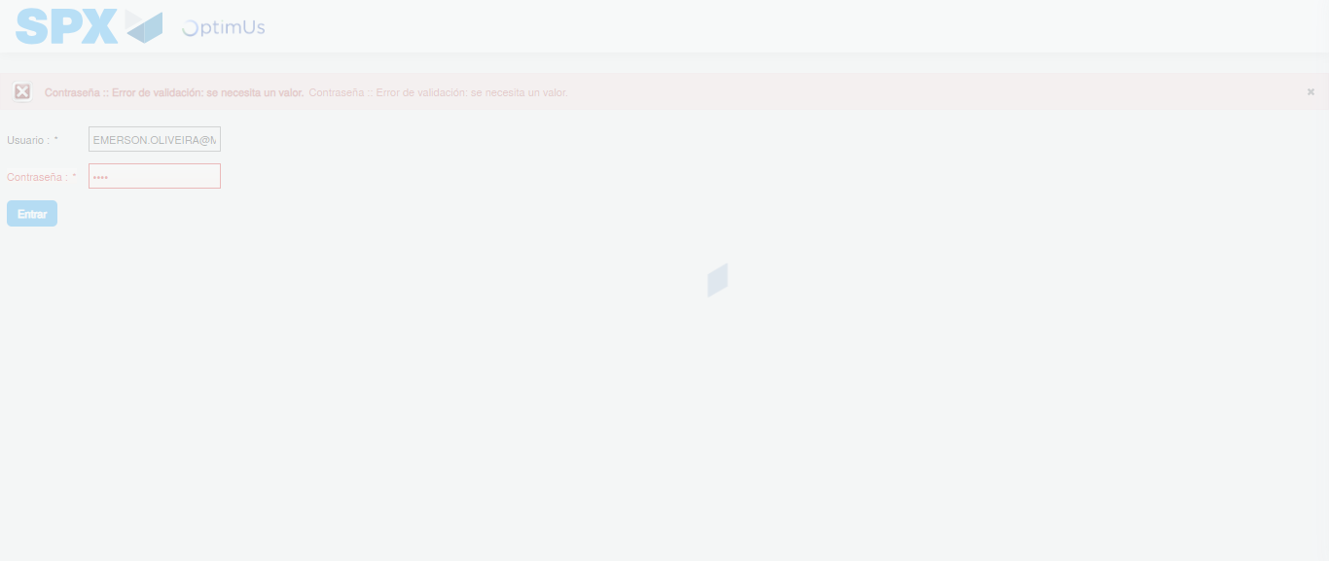Image file-name: QC_Testing-tc005_SPX_Dev5_Crear_Requisicion_Spot_Con_FAD_Tipo_Cobro_Project-1784669643761

Step 2 - Select to UEN and Access to Spot Buy Requisitions : UEN Correctly selected and Correct access
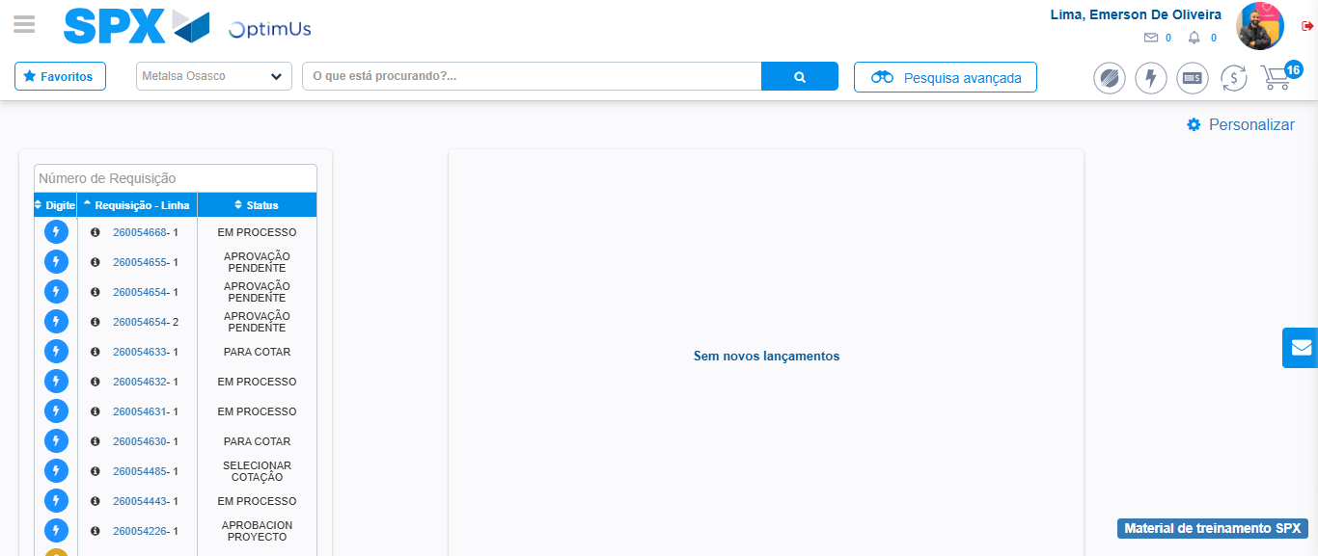Image file-name: QC_Testing-tc005_SPX_Dev5_Crear_Requisicion_Spot_Con_FAD_Tipo_Cobro_Project-1784669707639

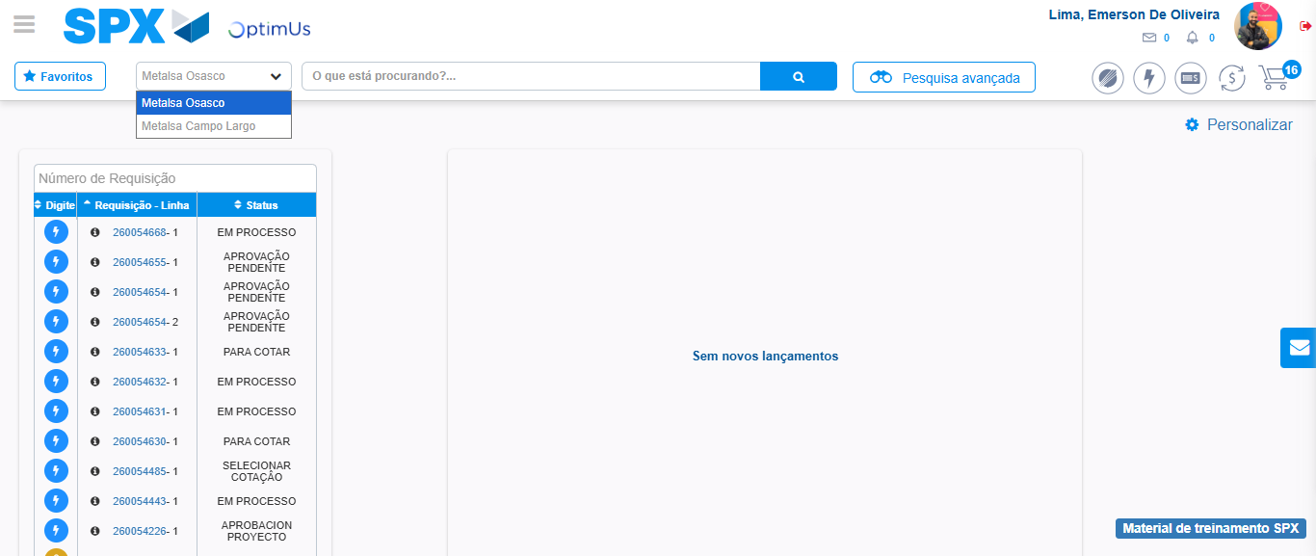Image file-name: QC_Testing-tc005_SPX_Dev5_Crear_Requisicion_Spot_Con_FAD_Tipo_Cobro_Project-1784669710293

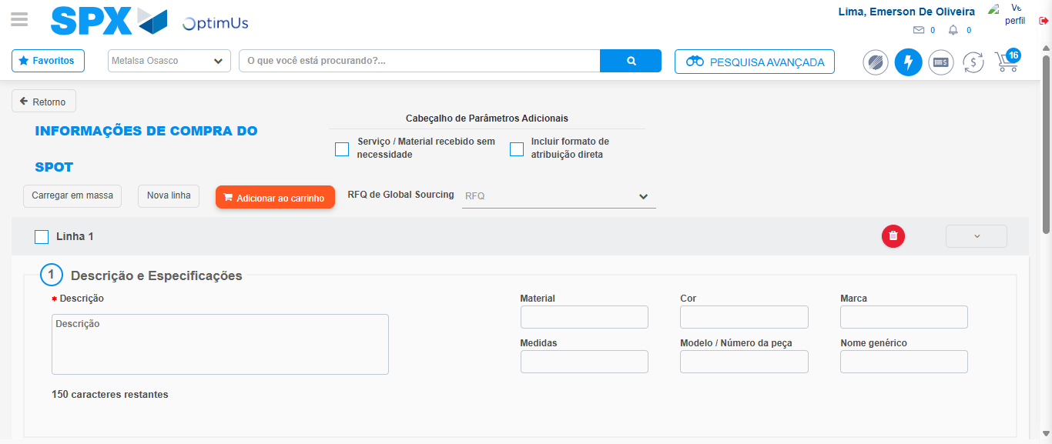Image file-name: QC_Testing-tc005_SPX_Dev5_Crear_Requisicion_Spot_Con_FAD_Tipo_Cobro_Project-1784669722814

Step 3 - Add FAD to Requisition: FAD Successfully Added
Image file-name: QC_Testing-tc005_SPX_Dev5_Crear_Requisicion_Spot_Con_FAD_Tipo_Cobro_Project-1784669723145

Image file-name: QC_Testing-tc005_SPX_Dev5_Crear_Requisicion_Spot_Con_FAD_Tipo_Cobro_Project-1784669723332

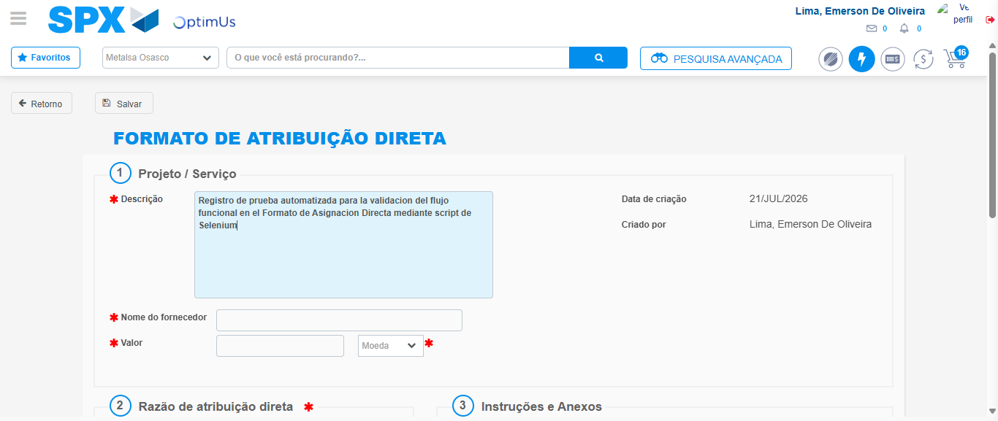Image file-name: QC_Testing-tc005_SPX_Dev5_Crear_Requisicion_Spot_Con_FAD_Tipo_Cobro_Project-1784669726379

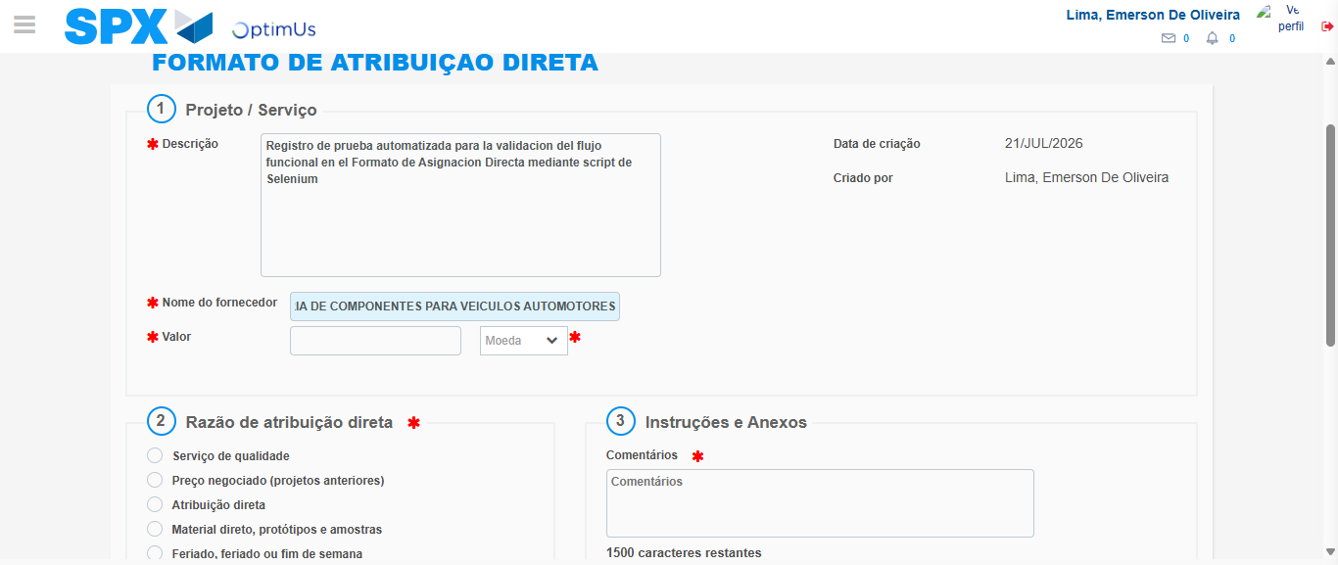Image file-name: QC_Testing-tc005_SPX_Dev5_Crear_Requisicion_Spot_Con_FAD_Tipo_Cobro_Project-1784669736172

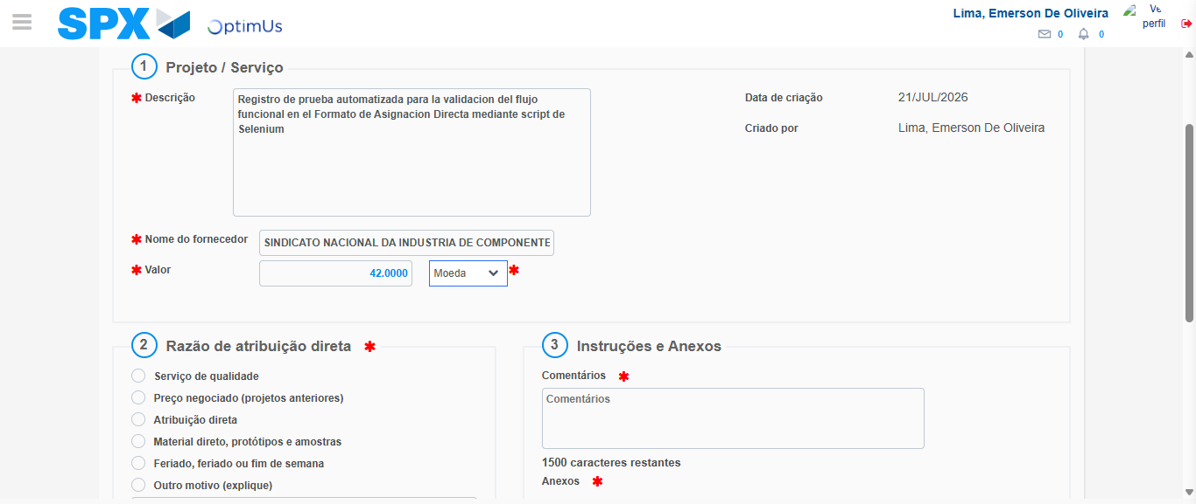Image file-name: QC_Testing-tc005_SPX_Dev5_Crear_Requisicion_Spot_Con_FAD_Tipo_Cobro_Project-1784669736638

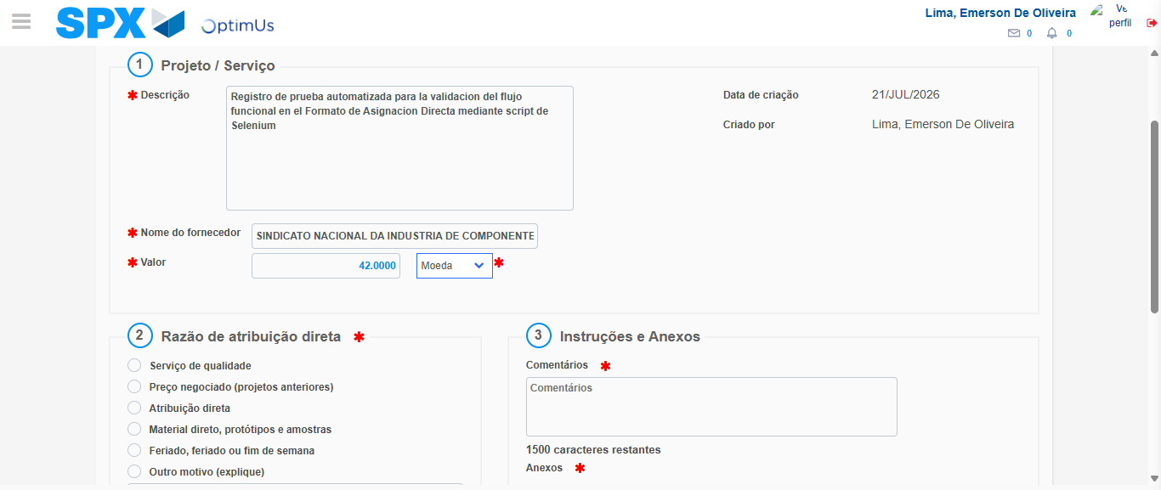Image file-name: QC_Testing-tc005_SPX_Dev5_Crear_Requisicion_Spot_Con_FAD_Tipo_Cobro_Project-1784669736869

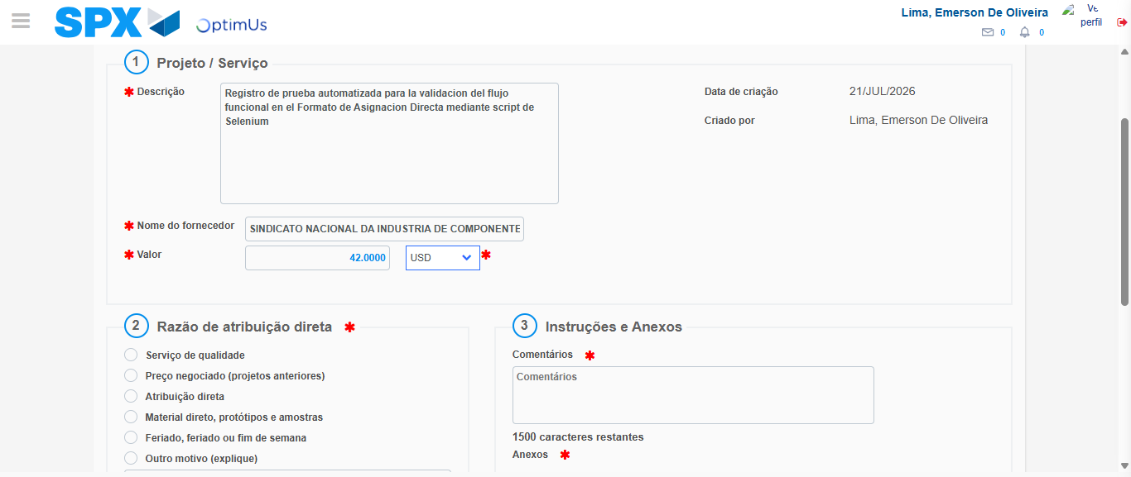Image file-name: QC_Testing-tc005_SPX_Dev5_Crear_Requisicion_Spot_Con_FAD_Tipo_Cobro_Project-1784669737358

Image file-name: QC_Testing-tc005_SPX_Dev5_Crear_Requisicion_Spot_Con_FAD_Tipo_Cobro_Project-1784669737601

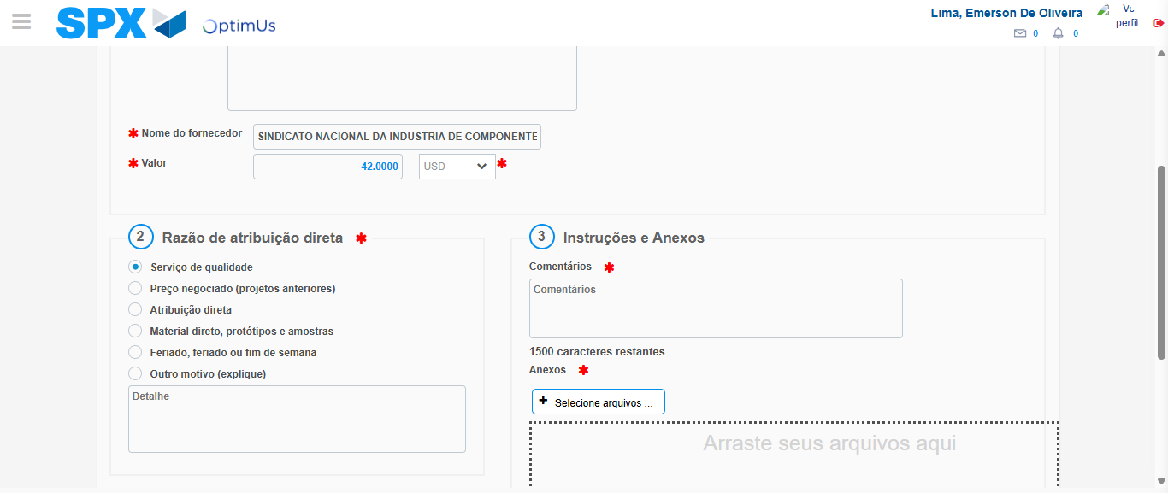Image file-name: QC_Testing-tc005_SPX_Dev5_Crear_Requisicion_Spot_Con_FAD_Tipo_Cobro_Project-1784669738528

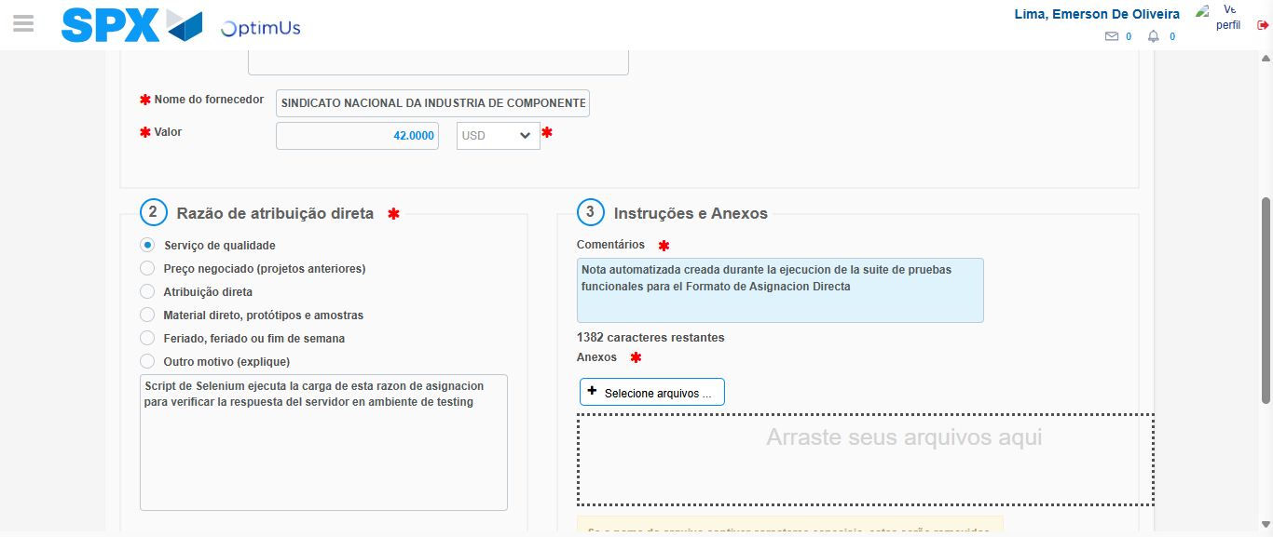Image file-name: QC_Testing-tc005_SPX_Dev5_Crear_Requisicion_Spot_Con_FAD_Tipo_Cobro_Project-1784669749845

Image file-name: QC_Testing-tc005_SPX_Dev5_Crear_Requisicion_Spot_Con_FAD_Tipo_Cobro_Project-1784669750677

Step 4 - Data Capture Spot Buy Requisition: Data captured correctly
Image file-name: QC_Testing-tc005_SPX_Dev5_Crear_Requisicion_Spot_Con_FAD_Tipo_Cobro_Project-1784669723145

Image file-name: QC_Testing-tc005_SPX_Dev5_Crear_Requisicion_Spot_Con_FAD_Tipo_Cobro_Project-1784669723332

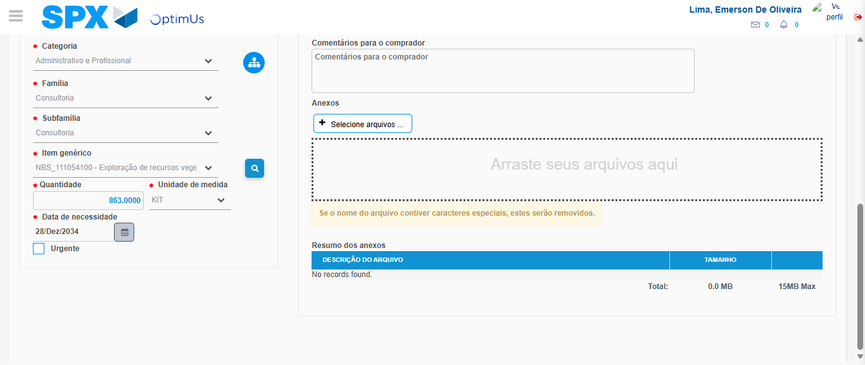Image file-name: QC_Testing-tc005_SPX_Dev5_Crear_Requisicion_Spot_Con_FAD_Tipo_Cobro_Project-1784669764979

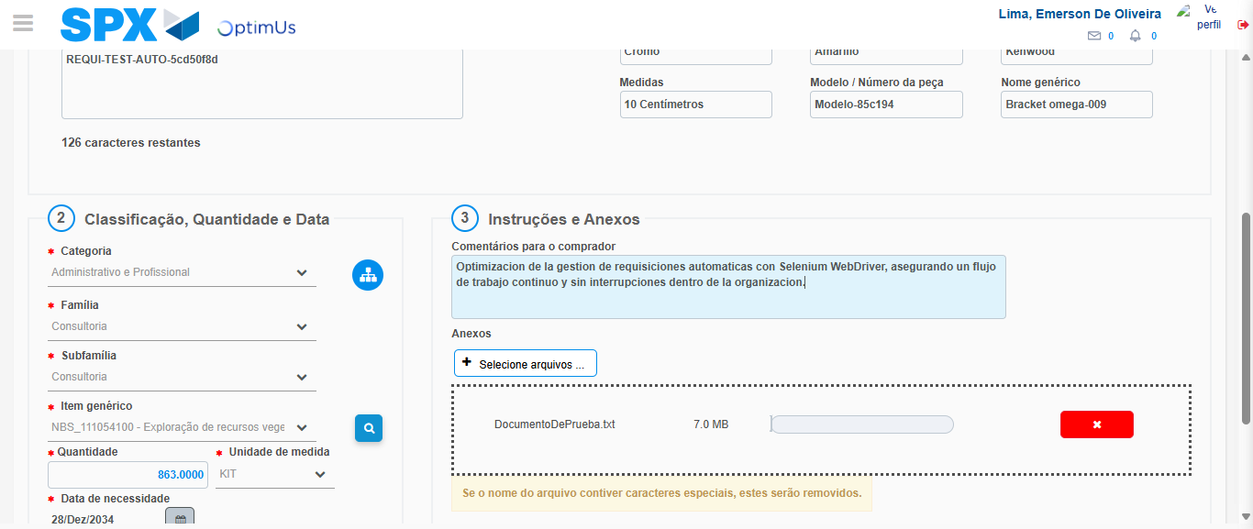Image file-name: QC_Testing-tc005_SPX_Dev5_Crear_Requisicion_Spot_Con_FAD_Tipo_Cobro_Project-1784669765882

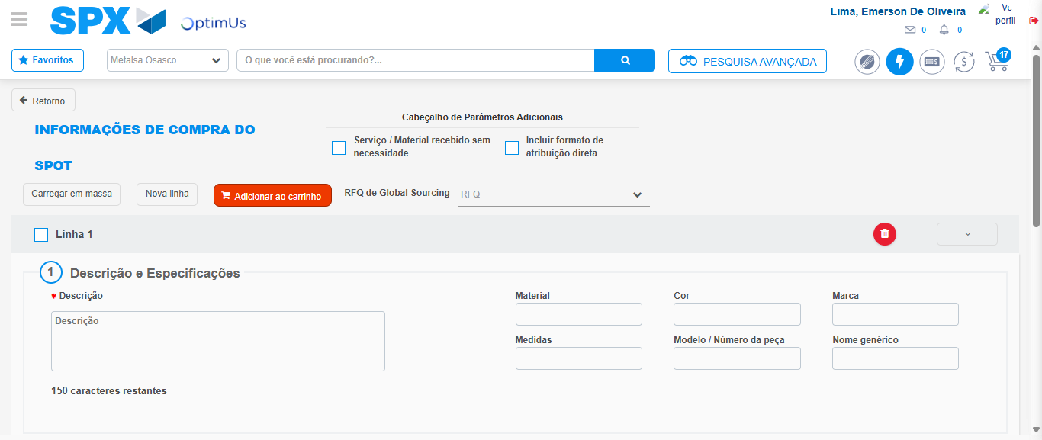Image file-name: QC_Testing-tc005_SPX_Dev5_Crear_Requisicion_Spot_Con_FAD_Tipo_Cobro_Project-1784669774486

Step 8 - Return to Main Page SPX : Return to Main Page SPX
Image file-name: QC_Testing-tc005_SPX_Dev5_Crear_Requisicion_Spot_Con_FAD_Tipo_Cobro_Project-1784669707639

Image file-name: QC_Testing-tc005_SPX_Dev5_Crear_Requisicion_Spot_Con_FAD_Tipo_Cobro_Project-1784669710293

Image file-name: QC_Testing-tc005_SPX_Dev5_Crear_Requisicion_Spot_Con_FAD_Tipo_Cobro_Project-1784669722814

Image file-name: QC_Testing-tc005_SPX_Dev5_Crear_Requisicion_Spot_Con_FAD_Tipo_Cobro_Project-1784669776743

Image file-name: QC_Testing-tc005_SPX_Dev5_Crear_Requisicion_Spot_Con_FAD_Tipo_Cobro_Project-1784669776934

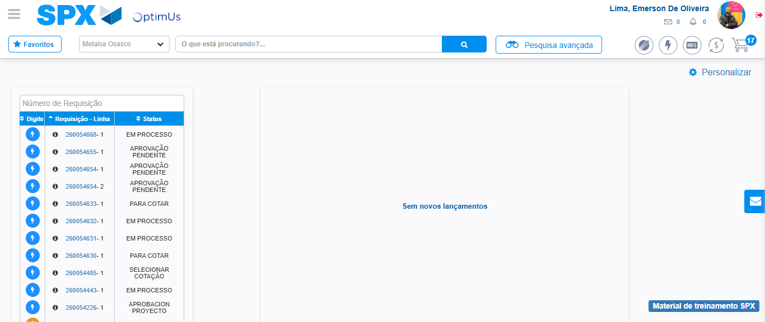Image file-name: QC_Testing-tc005_SPX_Dev5_Crear_Requisicion_Spot_Con_FAD_Tipo_Cobro_Project-1784669797936

Step 9 - Log Out : Log Out SPX
Image file-name: QC_Testing-tc005_SPX_Dev5_Crear_Requisicion_Spot_Con_FAD_Tipo_Cobro_Project-1784669798146

